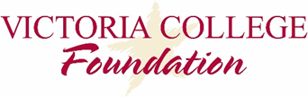
2019 Spring Faculty & Staff Grant Awards
Total Awards = $17,014.71

- Technology Services - $2,595.00
Attend Annual Instructure Convention for the Canvas Learning Management System.

- EMS – Public Service - $3,500.00
Costs associated with one-day cadaver lab for Paramedic class.

- Sports Center - $3,729.63
Folding chairs, storage caddie and cover for athletic events, intramurals and physical education classes.

- Distance Education & Instructional Technology - $1,500.00
Surface Pro 6 2-in-1 tablet.

- Cultural Affairs - $1,128.08
40 mini digital humidity and temperature meters to place in display cases at the Museum of the Coastal Bend.

- Science, Math and Physical Education - $2,280
Development of a new non-credit interim course to support student entering Human Anatomy and Physiology (Biology 2401)

- Workforce & Continuing Education - $1,132.00
Microphones and speakers for classrooms for ALL members.

- Marketing & Communications - $1,150
Acquire Honda generator

