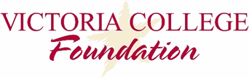
2017 Fall Faculty & Staff Grant Awards

- Allied Health-Vocational - $329.45
Online suicide prevention training course for faculty

- Humanities, fine Arts, Social Sciences - $846.11
Partial funding for faculty member to attend National Council for the Education of Ceramics Arts Conference

- Gonzales Center - $1,600.00
Partial funding to purchase student badge maker

- KEY Center - $200
Purchase of ACT, Sat and ATI TEAS Study Guides

- ADN Program - $3,500
Funding for on-site workshop for nursing faculty to develop exam questions and exam blueprint to prepare students for NCLEX exam.

- Social Sciences - $326
Partial funding for faculty member to attend EconoED 2017 Conference

- Cultural Affairs – $500
Assist with expenses to attend 2018 American Alliance of Museums Annual Meeting and Museum Expo

- Marketing & Communications - $995
Partial funding for employee to attend conference

